**TABLE OF CONTENTS**

* ABSTRACT
* INTRODUCTION
* SCOPE OF THE PROJECT
* NEED FOR THE PROJECT
* GOALS AND OBJECTIVES OF THE PROJECT
* IDEA AND UNIQUENESS
* COMPONENTS REQUIRED
* BLOCK DIAGRAM
* SOFTWARE FLOWCHART
* CODE DESCRIPTION / ANALYSIS
* CODE DESIGN
* SNAPSHOTS OF OUTPUT
* CONCLUSION
* FUTURE ENCHANCEMENT
* REFERENCES

**ABSTRACT**

The main objective of this project, is on the view of saving electrical energy by displaying the electricity bill equivalent to the electric energy consumed in terms of watt in the energy meter. This can be achieved by making simple changes in energy meter so that each and every individual can know the exact cost of the electric consumption in their home.

By doing so, even the illiterate people can be able to know the equivalent cost of the electric energy consumed in their homes. By acknowledging, the above mentioned system they can be able to realize the real fact of saving energy and they will start reducing the electric energy consumption in their homes and also they will be able to save their money.

Now a days, the energy consumption and energy distribution has become a big subject for discussion because of huge difference in energy consumption. In this regard, energy consumers are facing so many problems due to the frequent power failures another important reason for power cuts is due to the unlimited wastage of power or electric energy. In this aspect, to minimize the power cuts and to reduce the utilization of electric energy. A practical awareness can be created among the people and idea of saving electric energy too.

Here in this project we use single phase energy meter for the implementation of our project because most widely we use single phase connection for domestic usage. This project helps to save energy manually by the implementation of the automation system of this project, energy consumed can be measured accurately and the manual work can be reduced by this project. Hence the need has come to think in this line and a solution has to be emerged out.

**INTRODUCTION**

The electrical metering instrument technology has come a long way from the original bulky meters with heavy magnets and coils, there have been many innovations that have resulted in size and weight reductions that have resulted in size and weight reduction in addition to improvement in features and specifications .resolutions and accuracy of the meter have seen substantial improvements over the years.

Introduction of the digital meter in the later part of last century has completely changed the way of electrical parameters are measured. Starting with voltmeters and ammeters, the digital meter has conquered the entire spectrum of measuring instruments due to their advantages like ease of reading, better resolution and rugged construction of particular significance is the introduction of the electrical energy meter in the mid-eighties .now a days, the energy consumption and energy distribution has become a big subject for discussion because of huge difference in energy consumers are facing so many problems due to the frequent power failures; another important reason for power cuts is due to the unlimited wastage of power or electric energy. According to that the government should implement a policy, by introducing autonomous energy meters everywhere in domestic sector. Hence, the need has come to think on this line and a solution has to be emerged out.

**SCOPE OF THE PROJECT**

The main scope this project is to educate the people by letting their knowledge with the idea of electric bill generation and the calculation process behind it. By doing so even a school and uneducated people can be able to have the ideology of electric energy consumption and its equivalent cost easily. When the equivalent cost of the electricity consumed is displayed people will be aware of saving their money, when the power consumption increases steadily. At the same time electric energy will also be saved by this process.The implementation of this will only can be done with help of the government to conserve energy for the future use.

**NEED OF THE PROJECT**

Everything in today’s world is getting automated through advanced technology. Automation is like blessing .Automation feature is added in this project as well as there is no need of man power to calculate the equivalent cost of the electric energy consumption automatically.This also reduces the calculation process in the TNEB APP. Todays need of every individual in this world to get everything easily and freely.even though we cannot get everything fort free of cost we can reduce the work load and make simple and easy to handle.

So we have designed our project in this ideology it is a bi-directional one in which the equivalent cost of the electric energy consumed can be displayed in both the way :1.One way is that manually while pressing the button in the energy meter the equivalent amount cost get displayed in the LCD. 2. Another is GSM based technique the equivalent cost of the energy consumed is sent as a message to the consumer or user. Hence the need has to be fulfilled in this line.

**GOALS AND OBJECTIVES OF THIS PROJECT**

**GOALS AND OBJECTIVES:**

* + Main goal of this project is to save energy.
  + Reduce the un-necessary wastage of electricity.
  + Reduce financial risk.
  + Reduce the manual work.
  + Introducing the ideology of making people aware of conserving energy by displaying the equivalent cost of the energy consumed.
  + User friendly.

**IDEA AND UNIQUENESS OF THE PROJECT**

**IDEA:**

The main idea of this project is to display the equivalent cost of the energy consumed in the energy meter itself by the use of software coding for the calculation process.

Motive is to the make the people to realize the real fact of saving energy by displaying the equivalent cost if we do so they will get aware of increase in the bill amount of energy consumed, and they start reducing the usage of electric energy.

Hence the dual role of saving energy and energy conservation awareness can be created among the people practically.

**UNIQUENESS:**

The uniqueness of this project lies in the ideology of making everyone benefitted by conserving energy for the future generation by the people itself and saving their valuable money. Reducing the financial risk and demand for the power supply to the government.

**“**Creating the idea of electric bill generation and its calculation among each every individual.**”** Bi-directional process giving exact cost of the energy consumed via the LCD of the energy meter and through the sms by GSM based technology it can be referenced from anywhere else and it is updated daily w9ith respect to time automatically. **“**User friendly because even a school kid to our grandmother can operate it easily without the knowledge of electric bill generation.”

**COMPONENTS REQUIRED**

**COMPONENTS:**

* ARDUINO BOARD
* GSM MODULE
* 16X2 LCD
* DIGITAL ENERGY METER
* MAX 232
* OPTOCOUPLER 4N35
* RESISTORS
* CURRENT SENSORS
* CONNECTING WIRES
* BULB AND HOLDER
* SIM CARD
* POWER SUPPLY - TRANSFORMER
* MOBILE PHONE

**DESCRIPTION OF COMPONENTS:**

**AURDINO BOARD:**

**Arduino** is an [open-source hardware](https://en.wikipedia.org/wiki/Open-source_hardware) and [software](https://en.wikipedia.org/wiki/Open-source_software) company, project and user community that designs and manufactures [single-board microcontrollers](https://en.wikipedia.org/wiki/Single-board_microcontroller) and [microcontroller](https://en.wikipedia.org/wiki/Microcontroller) kits for building digital devices and interactive objects that can sense and control both physically and digitally. Arduino board designs use a variety of [microprocessors](https://en.wikipedia.org/wiki/Microprocessor) and controllers. The boards are equipped with sets of digital and analog [input/output](https://en.wikipedia.org/wiki/Input/output) (I/O) pins that may be interfaced to various expansion boards or [breadboards](https://en.wikipedia.org/wiki/Breadboards) (*shields*) and other circuits. The boards feature serial communications interfaces, including [Universal Serial Bus](https://en.wikipedia.org/wiki/Universal_Serial_Bus) (USB) on some models, which are also used for loading programs from personal computers. The microcontrollers are typically programmed using a dialect of features from the programming languages [C](https://en.wikipedia.org/wiki/C_(programming_language)) and [C++](https://en.wikipedia.org/wiki/C%2B%2B). In addition to using traditional [compiler](https://en.wikipedia.org/wiki/Compiler) [toolchains](https://en.wikipedia.org/wiki/Toolchains), the Arduino project provides an [integrated development environment](https://en.wikipedia.org/wiki/Integrated_development_environment) (IDE) based on the [Processing](https://en.wikipedia.org/wiki/Processing_(programming_language)) language project

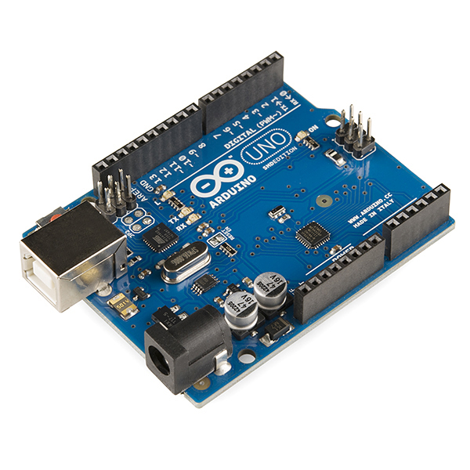

**MAX-232:**

The Max-232 IC is started by the maxim integrated products in 1987. It is an integrated circuit which converts the signals from the RS232 serial port to the proper signal which are used in the TTL compatible digital logic circuits. The MAX232 can convert the signals like RX, TX, CTS, and RTS and it is a dual driver/receiver. The driver increases the output voltage levels of TIA232 from a 5 volt supply to 7.5 volts by using the external capacitor and on chip charge pumps. The receiver reduces the input levels of the TIA232 from 25 volts to the standard voltage level, i.e. 5volts of TTL levels and there is a threshold of 1.3 volts and hysteresis of 0.5 volts for the receiver. Further the max232 IC is extended by the four receivers and transmitters simultaneously with eight receivers and transmitters which are MAX238 and MAX248 and there are many combinations of receivers and transmitters.

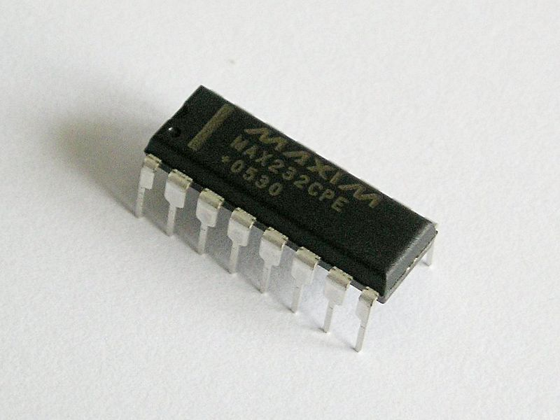

**GSM MODEM:**

A **GSM modem** is a specialized type of modem which accepts a SIM card, and operates over a subscription to a mobile operator, just like a mobile phone. From the mobile operator perspective, a GSM modem looks just like a mobile phone. When a GSM modem is connected to a computer, this allows the computer to use the GSM modem to communicate over the mobile network.  While these GSM modems are most frequently used to provide mobile internet connectivity, many of them can also be used for sending and receiving SMS and MMS messages. A GSM modem can be a dedicated modem device with a serial, USB or Bluetooth connection, or it can be a mobile phone that provides GSM modem capabilities. For the purpose of this document, the term GSM modem is used as a generic term to refer to any modem that supports one or more of the protocols in the GSM evolutionary family, including the 2.5G technologies GPRS and EDGE, as well as the 3G technologies WCDMA, UMTS, HSDPA and HSUPA.

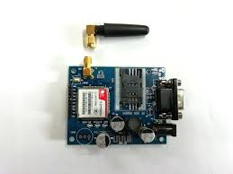

**OPTOCOUPLER:**

**4N35** is an **opt coupler integrated circuit** in which an infrared emitter diode drives a phototransistor. They are also known as opt isolators since they separate two circuits optically. These are used to couple two circuits without any ohmic contact. They allow one of the circuits to switch another one while they are completely separate. The first circuit is connected to IR diode while the other circuit with the phototransistor. The isolation ensures that no damage occurs in either of the circuits while the other one has a fault. An **opt coupler** is analogous to a relay which isolates two circuits magnetically. They differ with relays in the sense that they are smaller in size and allow fast operation. **4N35s** are commonly used in interfacing an electronic circuit with the parallel port of a computer.

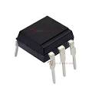

**DIGITAL ENERGY METER:**

An electric meter or energy meter is an essential device that goes with consumption of commercially distributed energy. It enables systematic pricing of energy consumed by individual consumer as it measures the amount of electrical energy consumed by a residence, business, or an electrically powered device [1]. They are typically calibrated in billing units, the most common one being the Kilowatts hour, which is equal to the amount of energy used by a load of one kilowatt over a period of one hour, or 3,600,000 joules.

Some meters measured only the length of time for which charge flowed, with no measurement of the magnitude of voltage or current. These were only suited for constant-load applications. Neither type is likely to be used today. In addition to metering based on the amount of energy used, other types of metering are available. Meters which measured the amount of charge (coulombs) used, known as ampere-hour meters, were used in the early days of electrification. These were dependent upon the supply voltage remaining constant for accurate measurement of energy usage, which was not a likely circumstance with most supplies.

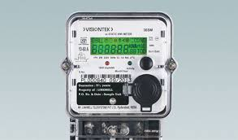

**LCD DISPLAY:**

LCD modules are very commonly used in most embedded projects, the reason being its cheap price, availability and programmer friendly. Most of us would have come across these displays in our day to day life, either at PCO’s or calculators. The appearance and the pinouts have already been visualized above now let us get a bit technical.

**16×2 LCD** is named so because; it has 16 Columns and 2 Rows. There are a lot of combinations available like, 8×1, 8×2, 10×2, 16×1, etc. but the most used one is the 16×2 LCD. So, it will have (16×2=32) 32 characters in total and each character will be made of 5×8 Pixel Dots.  A Single character with all its Pixels is shown in the below picture. 16x2 LCD Pixel

Now, we know that each character has (5×8=40) 40 Pixels and for 32 Characters we will have (32×40) 1280 Pixels. Further, the LCD should also be instructed about the Position of the Pixels. Hence it will be a hectic task to handle everything with the help of MCU, hence an **Interface IC like HD44780**is used, which is mounted on the backside of the LCD Module itself. The function of this IC is to get the **Commands and Data** from the MCU and process them to display meaningful information onto our LCD Screen.

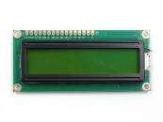

**BLOCK DIAGRAM:**

The power supply has been given to the transformer from there the power gets supplied to the energy meter and the load i.e. bulb. When the bulb starts glowing it consumes some amount of energy then the energy consumption is measured by the energy meter. When the flow of power increases the pulses in the energy starts increasing gradually. When it satisfies the below condition:

Pulse= (Pulse _ rate*watt*time)/ (1000*3600)

So pulses for 100 watt bulb in 60 seconds, with energy meter of 3200 imp/kwh pulse rate can be calculated as below:

Pulses=3200*100*60/1000*3600

Pulses = ~5.33 pulse per minute

The consumed energy pulses are converted into units. These units are taken as output from the energy meter and then they give as input to the AURDINO BOARD program.

The Arduino board then makes the calculation process and displays the result that is equivalent cost of the energy consumed in the interconnected LCD display.

This Arduino board connection is done in two ways one is connected to LCD and another connection is to the GSM MODEM there the given output i.e. the units equivalent cost is sent as message to the consumer’s mobile number with reference number of the Arduino board.

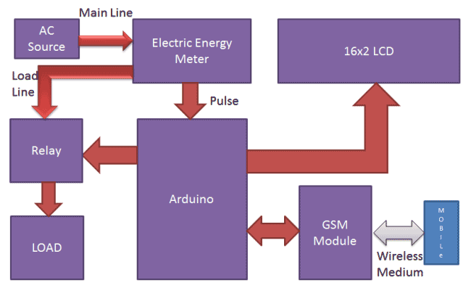

**CIRCUIT DESCRIPTION:**

Circuit connections for this **Wireless Electricity Meter Reading Project**, are shown in the diagram; we have used an [**Arduino UNO**](http://circuitdigest.com/arduino-uno-projects) for processing all the things used in project. A liquid crystal display is used for displaying the status of Units and remaining balance. Data pins of LCD namely RS, EN, D4, D5, D6, D7 are connected to Arduino digital pin number 7, 6, 5, 4, 3, 2. And Rx and TX pins of GSM module are directly connected to the TX and Rx pins of Arduino respectively. And GSM module is powered by using a 12 volt adaptor. A relay is used for switching electricity connection which is connected at pin 12 of Arduino though ULN2003 relay driver.

[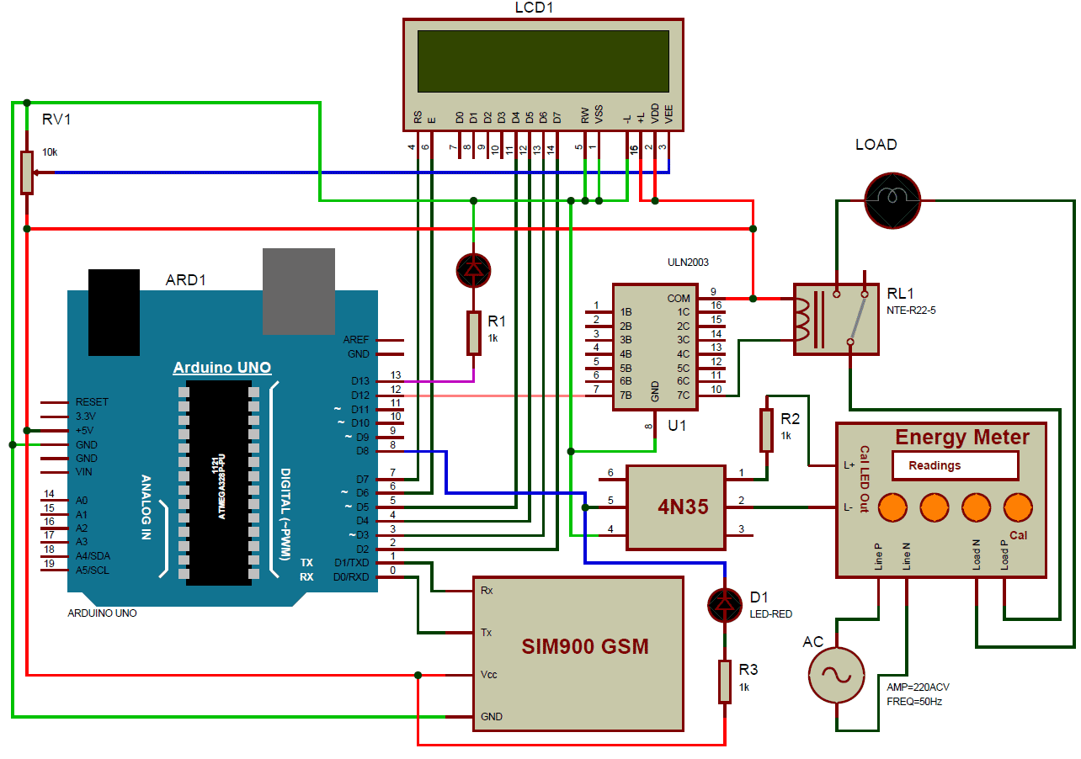](https://circuitdigest.com/fullimage?i=circuitdiagram_mic/prepaid-energy-meter-using-gsm-circuit-diagram_0.png)

**SOFTWARE FLOWCHART:**

The below represented flowchart and diagram is the schematic representation of the software process carried out inside the project:

### 

**ENERGY METER**

**AURDINO**

**BOARD**

LCDLLLLLLLL

**LCD DISPLAY**

**MOBILE PHONE**

**GSM MODEM**

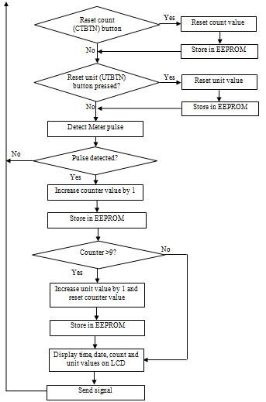

**CODE DESCRIPTION AND ANALYSIS**

**CODE ANALYSIS:**

### **CALCULATION OF PULSES AND UNITS:**

Before proceeding for the calculations, first we have to keep in mind the pulse rate of energy meter. There are two pulse rates of energy meter first is 1600 imp/kwh and second is 3200 imp/kwh. So here we are using 3200 imp/kwh pulse rate energy meter.

So first we need to calculate the Pulses for 100watt, **means how many times Pulse LED will blink in a minute**, for the load of 100 watts.

Pulse= (Pluse_rate*watt*time)/ (1000*3600)

So pulses for 100 watt bulb in 60 seconds, with energy meter of 3200 imp/kwh pulse rate can be calculated as below:

Pulses=3200*100*60/1000*3600

Pulses = ~5.33 pulse per minute

To calculate Power factor of a single pulse, means how much **electricity will be consumed in one pulse**:

PF= watt/ (hour*Pulse)

PF=100/60*5.33

PF=0.3125 watt in a single pulse

Units= PF*Total pulse/1000

Total pulses in an hour is around 5.33*60=320

Units = 0.3125*320/1000

Units = 0.1 per hour

**If a 100 watt bulb is lighting for a day** then it will consume

Units =0.1*24

Units = 2.4 Units

And suppose unit rate is at your region is 5 rupees per unit then

You have to pay for 2.4 Units Rest:

Rupees= 2.4*5 = 12 rupees

**CODE DESCRIPTION** **:**

First of all we include required library and Define pins & variables that are required in our project. This can be seen in first few lines of our program code below.

After it we initialize the LCD, serial communication, GSM and display some message message.

After this in loop function we read serial received data if any. And reads pulse from energy meter and show units and balance on LCD.

Void setup ()

{

lcd.begin (16, 2);

Serial. Begin (9600);

Pin Mode (led, OUTPUT);

.. ...

... ....

lcd.print ("Circuit ");

lcd.setCursor (0, 1);

Delay (2000);

lcd.print ("GSM Initilizing...");

gsm_init ();

.. ...

... ....

 After this in loop function we read serial received data if any. And reads pulse from energy meter and show units and balance on LCD.

void loop ()

{

Serial Event ();

Rupees=EEPROM.read (1);

Units=rupees/5.0;

lcd.setCursor (0, 0);

lcd.print ("Units :");

.. ...

... ....

Void init_sms (), void send_data (String message), and void endisms () functions have been used to send SMS.

gsm_init () function is used for initializing the GSM module for get ready to operate with the system. In this we first sends AT command to know whether GSM module is connected or not. After it we turned off the echo and then check the network.